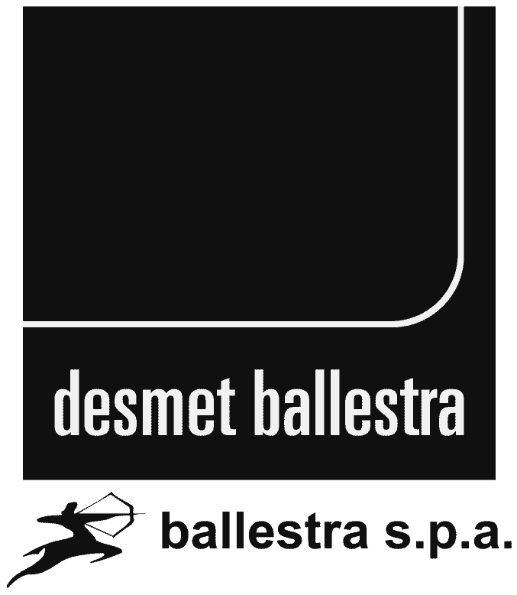 | SABIZ PLANT | Spec.: | 2F11-40-278
 | SABIZ PLANT | Rev.: | 0
 | JOB 2F11 | Sheet: | 1 | of | 13

DDRY

basis of design

&

utilities consumption

0 | First issue | 02/02/2012 | GDI
Rev. | Descrizione / Description | Data / Date | Autore / Author
The master version of this document is stored as a digital file in a software archive - Approval process is digitally managed, details do not show on paper copies

INDEX

1. SITE CONDITIONS 3
2. LAYOUT AND BATTERY LIMITS DEFINITION 4
3. PLANT CAPACITY 5
3.1 Solid raw materials pneumatic transport 5
3.2 Raw materials dosing 5
3.3 Spray-drying 5
3.3.1 Base powder coating 5
3.4 Post-blending 5
4. PRODUCT QUALITY 6
5. RAW-MATERIALS AND CHEMICAL SPECIFICATION 6
5.1 RAW MATERIALS CHARACTERISTICS 7
6. RAW MATERIAL AND UTILITIES CONSUMPTION 12
7. RECOVERIES AND REPROCESSING 12
8. EFFLUENTS CHARACTERISTICS 13

SITE CONDITIONS

Site data are indicated here below.

The design and the selection of the plant equipment/materials will be made according to the following site conditions:

Climatic conditions

- Design air temperature : 17°C min. 40°C max.

- Wet bulb temp. °C : min. 18.3, max. 29.9

- Dry bulb temp. °C : min. 23, max. 32

- Rel. Umidity % : 65 - 85

Geographic/geophysics data

- Height above sea level mt. : sea level.

- Earthquake classification (ANSI 58.1) :Very low risk

Electric data : 415 Volt 50Hertz, 3 Phases.

LAYOUT AND BATTERY LIMITS DEFINITION

The plant layout is shown in the drawing: 2F11-20-101
The spray-drying plant layout has been studied in accordance with the continuous operation of the plant.

No intermediate storage of base powder has been foreseen. A final storage of powder has been considered, from the storage silos the powder shall be sent to the packaging units.

Battery Limits

The plant battery limits are defined at 1 m outside the building where the plant will be installed or, for outdoor installation, 1 m outside the occupied area perimeter.

For what concerns the electric power supply, the battery limits are defined at the feeding point of the electric power distribution panel.

PLANT CAPACITY

3.1 Solid raw materials pneumatic transport

The nominal capacity of the pneumatic transport to day silos is 6 t/h for each compressor line, of the following solid raw materials

- sodium tripolyphosphate
- sodium sulphate
- sodium carbonate
- zeolite (OB, CMC and minors)

3.2 Raw materials dosing

The capacity of these units corresponds to the nominal capacity of spray-drying unit, by processing slurry at 60-65% (in accordance with the formulation).

3.3 Spray-drying

This unit is designed for a nominal capacity of 8.000 Kg/h of base detergent powder coming from the bottom of the spray-drying tower, by operating continuously and at the following process conditions:

- slurry concentration: 65%

- hot air inlet temperature to
the spray-drying tower: 350°- 400°C

- base powder moisture content: 9 %

- bulk density 300 gr./l

The capacity could be higher and lower than the nominal one for different running condition and bulk density. In particular nominal spray-drying capacity will be reduced in case of moisture content in the base powder, lower than 5%.

3.3.1 Base powder coating
The unit is designed to add to 8000 Kg/h of base powder, a stream of zeolite powder (up to 10%), as coating agent.

3.4 Post-blending

The post-blending unit is designed for to add the following component to the base spray-dried powder, as required by range of formulation.

- Zeolite 2 - 6%
- speckles 1 - 3%
- enzymes 0 - 1 %
- perfume 0,1 – 0,5%

PRODUCT QUALITY

The detergent powder coming from the spray-drying tower will be white without coloured spots, in form of beads of dimension 0,2 – 2,5 mm.

The density of the product (250 - 450 g/l) and the moisture content (up to 10-15%) depend on the slurry composition and the drying conditions and can be adjusted, within a certain range, by acting on the process parameters, i.e. slurry ageing time and temperature, spray-drying pressure, hot air temperature, exhaust air temperature, etc.

In particular product formulation range listed here below:

Active matter (as 100%) | 20 – 30%
Sodium sulphate | 18 – 24%
Sodium silicate (as 100%) | 5 – 8%
Polymer (as 100%) | 0 – 3%
STPP | 20 – 27%
Sodium carbonate | 18 – 24%
CMC | 0 – 2%
Zeolite | 0 – 5%
O.B. | 0 – 0,5%
Perborate (post dosed) | 0 – 4%
Zeolite (post dosed) | 0 – 10%
Enzymes (post dosed) | 0,2 – 0,4%
Speckles (post dosed) | 0 – 2%
Perfume | 0,2 – 0,4%
Moisture | 8 – 10%

Bulk density finished product 300 – 350 g/lt

RAW-MATERIALS AND CHEMICAL SPECIFICATION

Raw-materials having the following shown characteristics are supposed to be made available at battery limits.

5.1 RAW MATERIALS CHARACTERISTICS

The characteristics of main raw materials involved in the process are listed in the annexed specifications, related to the good commercial products available on the market.

Title Table

- Anhydrous sodium
tripolyphosphate 34
- Caustic soda 13
- Sodium sulphate 45
- Sodium carbonate 42
- Sodium silicate 35
- LABS 39
- Non-ionic 30
- Perfume 32

Ballestra is available to study the possibility of using raw materials with different characteristics upon Client's request as well as to provide any assistance required to procure these materials on the international market at the best competitive terms.

TABLE 34

SODIUM TRIPOLYPHOSPHATE
(Na₅P₃O₁₀)

- Aspect White powder
without impurities
- Sodiumtripolyphosphate % 93 min.
- Sodium pyrophosphate % 4 max.
- Sodium sulphate 2,5 max.
- Tot'al water % 0,3 max.
- Total P205 56 min.
- Orthophosphate traces
- Particle size (sieve ASTM):
passing through sieve N. 100 meshes 90% min.
passing through sieve N. 200 meshes 70% min.
- Density 0,7-1,000 Kg/lt.
- pH = 1% in H20 9,2-10
- Fe 30-70 ppm
- Molecular weight 368

Aspect: free flowing white powder. H₂0 10% solution is free from deposit and suspended matter.

Supply: in bags, preferably paper bags (min. 400 to max 600 mm wide)

TABLE 13

SOLID CAUSTIC SODA
(NaOH)

- NaOH titer 98% min.
- Total impurities 2% max.
(Sodium carbonate) ( l% max.)
(Chlorides) ( 2% max.)
(Iron) ( 100 ppm max.)
- Molecular weight 40

In formulation the caustic soda is generally used in solutions of 40% concentration with specific gravity equal to 1,43 Kg/dm³.

Note: the NaOH to be used for neutralization of alcohols and of sulphonated ethoxylated alcohols must have an iron content below 5 ppm.

Supply: in bags, preferably paper bags,
(400 min. to 600 max. mm. wide)

TABLE 45

SODIUM SULPHATE
( Na₂SO₄)

- Aspect white powder
without impurities
- H20 0,2% max.
- Water insoluble 0,02% max.
- pH of 1% solution 6 - 7
- Iron 50 ppm max.
- 10% solution coloring about colorless
- Bulk density 1.1 - 1.3 Kg/lt
- H2S04 0,01 max.
- Molecular weight 142
- Particle size (Sieve ASTM)
sieve waste N. 100 meshes 60% max.

The powder should be free-flowing and the 10% solution free from suspended matter and approaching the neutral pH.

Supply: in bags, preferably paper bags
(400 min. to 600 max. mm wide)

TABLE 42

SODIUM CARBONATE
(Formula: Na₂CO₃)

- Aspect Free flowing
white powder
- Na2C03 98% min.
- Si02 + A1203 0,05% max.
- NaCl 0,50% max.
- Na2S04 0,05% max.
- Iron 70 ppm max.
- H20 0,05% max
- Bulk density 0,6-0,7 Kg/lt
- Molecular weight 106

Supply: in bags, preferably paper bags
(400 min. to 600 max. mm wide)

TABLE 35

SODIUM SILICATE (liquid)

- Aspect Liquid, limpid, colorless
- Density = 150C 50 Be'
- Ratio Si02/Na20 2,2
- Total solids 44% min.
- Working temperature min. 50°C
- Solution viscosity at 40 Bà 48 Cps at 50°C

TABLE 39

DODECYLBENZENE SULPHONIC ACID
From linear DDB M.W. 245)

- Active matter content 97%
- Free oil max. 1.25%
- H2S04 max. 1.5%
- H₂O balance
- Color : from branched DDB 155 Klett
from linear DDB 60 Klett (*)

If color is over 60 Klett, the neutralized product has to be bleached with a small amount of sodium hypochlorite.

TABLE 30

NON IONICS (liquid)

Alcohol C₁₂ -C₁₈ with 9 ethylene oxyde molecules

- Aspect at 25'C liquid, viscous
- Viscosity at 25'C 300 c.s.
- Color colorless
- Hydroxyl number 90
- Melting point O°C
- pH (l% solution) neutral-slightly alkaline
- Active matter 100%
- Density at 25'C 1

Supply: in drums (200 Kg)

TABLE 32

PERFUME

Liquid: according to choice

Note: The suppliers will have at their disposal a great number of natural synthetic oils, oily exactly like or suspended in solvents for the different uses in detergents field (powders, liquids, creams and solid). Specifications are to be defined every time.

Supply: in drums

6. RAW MATERIAL AND UTILITIES CONSUMPTION

The raw materials consumption depends on the formulation processed.

The operating losses are less than 0,1% of the base detergent powder produced.

- Compressed air (0°C d.p.): 80Nm3/hr @ 7 barg (peak consumption 120 Nm3/hr)

- Compressed air (-20°C d.p): 220 Nm3/hr @ 7barg (peack consumption 280Nm3/hr)

- Saturated steam: 350kg/hr @ 6barg

- Diesel Oil: 300 kg/hr (1)

- Natural Gas: 370 kg/hr (1)

NOTE:
- Figure obtainable at follow operating conditions:
Slurry concentration: 65%
Slurry temperature: 65°C
Moisture content in base powder: 9%
Ambient temperature: 25°C
Hot temperature at Tower inlet: 350°C
Base powder flowrate: 8’000kg/hr

7. RECOVERIES AND REPROCESSING

Liquid recoveries

Water from mechanical seals, etc. are recovered in the water tank and recycled to the process.

Dry scraps

- Waste (dimensional) from sieve (about 1%) is recycled in the process
- Fine dust from belts, process machines and pneumatic transport are recycled to the process.

Off-specs re-blending

- The product discharged from the packaging machine can be recovered and recycled in the airlift suction hopper.

8. EFFLUENTS CHARACTERISTICS

There are no liquid effluents during normal plant operation.

Gas effluent is the air coming from the sleeve filters of pneumatic transport, the spray drying tower exhaust air sleeve filter and the air lift filter.

The expected dust content in these air streams is 20 mg/m³.

